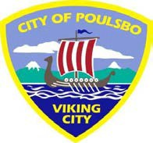
CITY OF POULSBO
2026 LODGING TAX GRANT APPLICATION

Applicant/Organization Information

Public  Non-Profit Private  Other  Name Other________________________________
Name
Address
Website  State  Zip |  |  |  | Email
Organization Purpose or Mission:
Contact Person
Name |  |  | Number of Years  of involvement with organization
Title
Email |  |  |  | Phone

Overall Tax Grant Request Information
What Target Market (demographic) is your organization going to attract?

Project Number | 2026 Project Title | Number of People Served by this Project | Funding  Request  from the  City of Poulsbo | Organization  Match | Total  Project  Cost
#1
#2
#3
#4
 | TOTALS REQUESTED
THIS TABLE PROVIDES A SUMMARY OF PROJECTS REQUESTING FUNDING. ALL EVENTS REQUESTING FUNDING ARE TO BE FURTHER DESCRIBED ON THE FOLLOWING DETAILED APPLICATION PAGES IN SECTON 1.
Section 1. Title and Descriptions of Project Listed on page 1 of application
If additional project pages are needed, please attach to the back of the application

Project #1 Title Project Description

Funding Requested Breakdown |  | Estimated Funding
Please list other:  (ex//promotional items) | Advertising
Please list other:  (ex//promotional items) | Operations
Total Funding Request from the City of Poulsbo:

Funding Sources for this Project (List all firm commitments to date):
Source: | Amount
Total Organization Match Funding:

the Totals of the two above tables should add up to “Total Project Cost” on page 1
List any other sources of funding your organization will apply for:

Source: | Amount: | Date of Funding Determination:
How will this grant be used? Be as detailed as possible: What mediums of advertising will be purchased? How will you distribute the information? How will you collect data to prove the tourism and lodging?

Identify the specific tourism audience/market? How will you use these funds to target travelers
more than 50 miles from Poulsbo?

How will this project be financed in the future?

Project #2 Title Project Description

Funding Requested Breakdown |  | Estimated Funding
Please list other:  (ex//promotional items) | Advertising
Please list other:  (ex//promotional items) | Operations
Total Funding Request from the City of Poulsbo:

Funding Sources for this Project (List all firm commitments to date):
Source: | Amount
Total Organization Match Funding:

the Totals of the two above tables should add up to “Total Project Cost” on page 1
List any other sources of funding your organization will apply for:

Source: | Amount: | Date of Funding Determination:
How will this grant be used? Be as detailed as possible: What mediums of advertising will be purchased? How will you distribute the information? How will you collect data to prove the tourism and lodging?

Identify the specific tourism audience/market? How will you use these funds to target travelers
more than 50 miles from Poulsbo?

How will this project be financed in the future?

Project #3 Title Project Description

Funding Requested Breakdown |  | Estimated Funding
Please list other:  (ex//promotional items) | Advertising
Please list other:  (ex//promotional items) | Operations
Total Funding Request from the City of Poulsbo:

Funding Sources for this Project (List all firm commitments to date):
Source: | Amount
Total Organization Match Funding:

the Totals of the two above tables should add up to “Total Project Cost” on page 1
List any other sources of funding your organization will apply for:

Source: | Amount: | Date of Funding Determination:
How will this grant be used? Be as detailed as possible: What mediums of advertising will be purchased? How will you distribute the information? How will you collect data to prove the tourism and lodging?

Identify the specific tourism audience/market? How will you use these funds to target travelers
more than 50 miles from Poulsbo?

How will this project be financed in the future?

Project #4 Title Project Description

Funding Requested Breakdown |  | Estimated Funding
Please list other:  (ex//promotional items) | Advertising
Please list other:  (ex//promotional items) | Operations
Total Funding Request from the City of Poulsbo:

Funding Sources for this Project (List all firm commitments to date):
Source: | Amount
Total Organization Match Funding:

the Totals of the two above tables should add up to “Total Project Cost” on page 1
List any other sources of funding your organization will apply for:

Source: | Amount: | Date of Funding Determination:
How will this grant be used? Be as detailed as possible: What mediums of advertising will be purchased? How will you distribute the information? How will you collect data to prove the tourism and lodging?

Identify the specific tourism audience/market? How will you use these funds to target travelers
more than 50 miles from Poulsbo?

How will this project be financed in the future?

Section 2. State law RCW 67.28.1816(2) requires and submits organizations potential economic impact as outlined and by the WA Joint Legislative Audit and Review Committee. Review previous state of WA Lodging Tax Expenditures: https://leg.wa.gov/jlarc/LodgingTax/default.html

All recipients must submit an annual report to the municipality describing the count of number of people based on projects that supports an event or facility:
Below is an example of our reporting form that your organization will be required to complete if approved for funding. Please read the definitions of how to count methods of attendance by click here: https://cityofpoulsbo.com/Counting-Methods-Definitions.pdf
For a full copy of this report, please contact Lin Hino, lhino@cityofpoulsbo.com

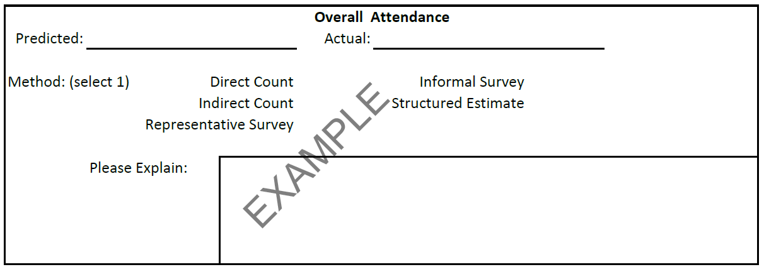

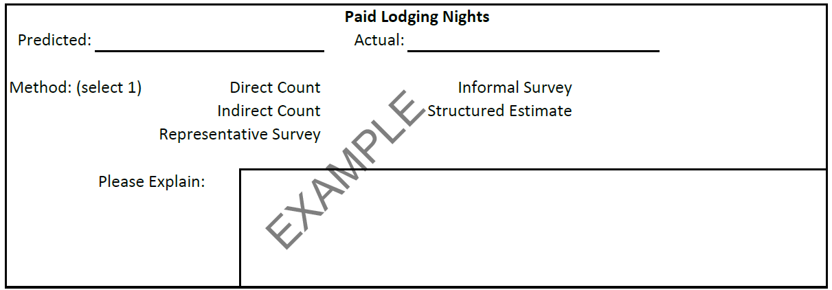

Section 3. Additional information your organization would like to include

Ex//Describe the prioritization of the projects and why. Outline how you are meeting the emphasized committee considerations?
Section 4. Application Certification

I attest and affirm I am an authorized agent of the organization/agency applying for funding and the information I have provided in this application is true, complete, and accurate. I understand and agree to the following:
- The Lodging Tax Funds, for which the organization/agency is applying, can only be used in accordance with the purposes outlined in RCW 67.28.
- If awarded, the applicant organization/agency will enter into a Tourism Promotion Services Agreement with the City.
- If awarded, the City of Poulsbo will only reimburse those costs actually incurred by the organization/agency and only after the service is rendered, or paid for if provided by a third party, and a signed City of Poulsbo payment form (or other form acceptable to the City) has been submitted to the City, including copies of invoices and payment documentation.
- The agency will be required to submit a mid-year and end-of-the-year report documenting economic impact results in a format determined by the City.
Signature | Title | Date

