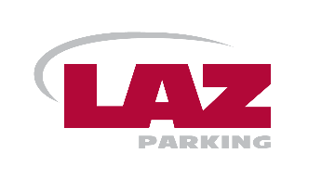

REGARDING REPARKING:

Poulsbo Municipal Code 10.12.050: Moving and reparking in same time zone or block.
Where a time limit is established by official signs, no vehicle may be reparked on either side of the same street in the restricted time zone in order to extend the vehicle’s parking time beyond the time limits established. For purposes of this section, a vehicle shall be deemed to be reparked and in violation of this section despite any movement of the vehicle unless the vehicle is moved to another street with a different street name than the street the vehicle was originally parked upon. It is no defense that the vehicle had been moved out of the zone for less than one hour before reparked in that zone. (Ord. 2007-40 § 7, 2007: Ord. 2005-17 § 1 (part), 2005; Ord. 83-39 § 10, 1983)

EXAMPLE SCENARIOS:
Note: King Olaf Public Lot, Big Anderson Lot and Little Anderson Lot are each considered as a separate “street.”
- If someone parks in the King Olaf Public Lot and reaches their time limit and then moves their car to another space in the King Olaf Public Lot, they will get a citation.
- If someone parks in the King Olaf Public Lot and reaches their time limit and then moves to 3rd Ave their time will start over again. Each time they go to a NEW Time-Limited area, they get the ability to park for as long as that time-limit allows.
- If someone parks in the King Olaf Public Lot and reaches their time limit and then moves to 3rd Ave and reaches their time limit there and then moves to Jensen Way will have their time start over again. Each time they go to a NEW Time-Limited area, they get the ability to park for as long as that time-limit allows.
- If someone parks in the King Olaf Public Lot and reaches their time limit and then moves to 3rd Ave and reaches their time limit and then moves back to the King Olaf Public Lot, they will get a citation. If they leave a certain time-limited area and come back to that same area, it would be the same as if they had not left the area at all. In a 24hr period, parkers cannot move back to areas where they have already parked.

For questions please email: DOWNTOWNPOULSBO@LAZPARKING.COM

